

Placement Empowerment Program
Cloud Computing and DevOps Centre

Phishing Detection Web Application

Members: Janarthanan N Department: CSE
Abdur Rahman MR Department: CSE
Saravana Krishnan J Department: IT



Phishing Detection Web Application

Project Overview
The Phishing Detection Web Application is a cloud-native, real-time tool designed to combat phishing threats by analyzing URLs and classifying them as legitimate ("Real") or malicious ("Phishing"). Leveraging Amazon Web Services (AWS) and a pre-trained machine learning model, this application offers a user-friendly interface accessible via any web browser. It serves as both a practical security tool and a demonstration of integrating machine learning, cloud computing, and infrastructure-as-code for scalable, secure solutions.
Objective: Enhance online security by empowering users to identify phishing websites instantly while showcasing advanced technical capabilities in cloud architecture and AI-driven cybersecurity.
Status: Fully deployed and operational as of March 26, 2025.

Key Feature
1. Real-Time URL Analysis
  - Users input a URL and receive an immediate prediction on its legitimacy.
  - Results are displayed clearly as "Real" or "Phishing" on the webpage.

2. Machine Learning Powered
  - Employs a pre-trained model to extract and evaluate URL features (e.g., domain structure, length, special characters).
  - Delivers high-accuracy predictions based on extensive training data.

3. User-Friendly Interface
  - Hosted as a static website, requiring no installation or technical knowledge.
  - Accessible globally via a single URL.

4. Scalable and Secure Architecture
  - Built on AWS for elasticity, reliability, and secure request handling.
  - Deployed with Terraform for consistent, repeatable infrastructure setup.

How It Works
1. User Interaction
A user navigates to the static website, enters a URL in the provided text field, and clicks "Check URL."
2. Prediction Process
  - The frontend sends the URL via a POST request to an API Gateway endpoint.
  - The API Gateway triggers an AWS Lambda function, which uses a pre-trained machine learning model to analyze the URL.
  - Features are extracted (via FeatureExtractor.py), and the model (stored in phishing_model.pkl) predicts the outcome.
3. Result Delivery
  - The Lambda function returns the prediction to the API Gateway, which relays it to the frontend.
  - The webpage updates to display the URL and its classification ("Real" or "Phishing").

Cloud Architecture
The following diagram illustrates the cloud architecture of the Phishing Detection Web Application, highlighting the flow of data and interactions between components:
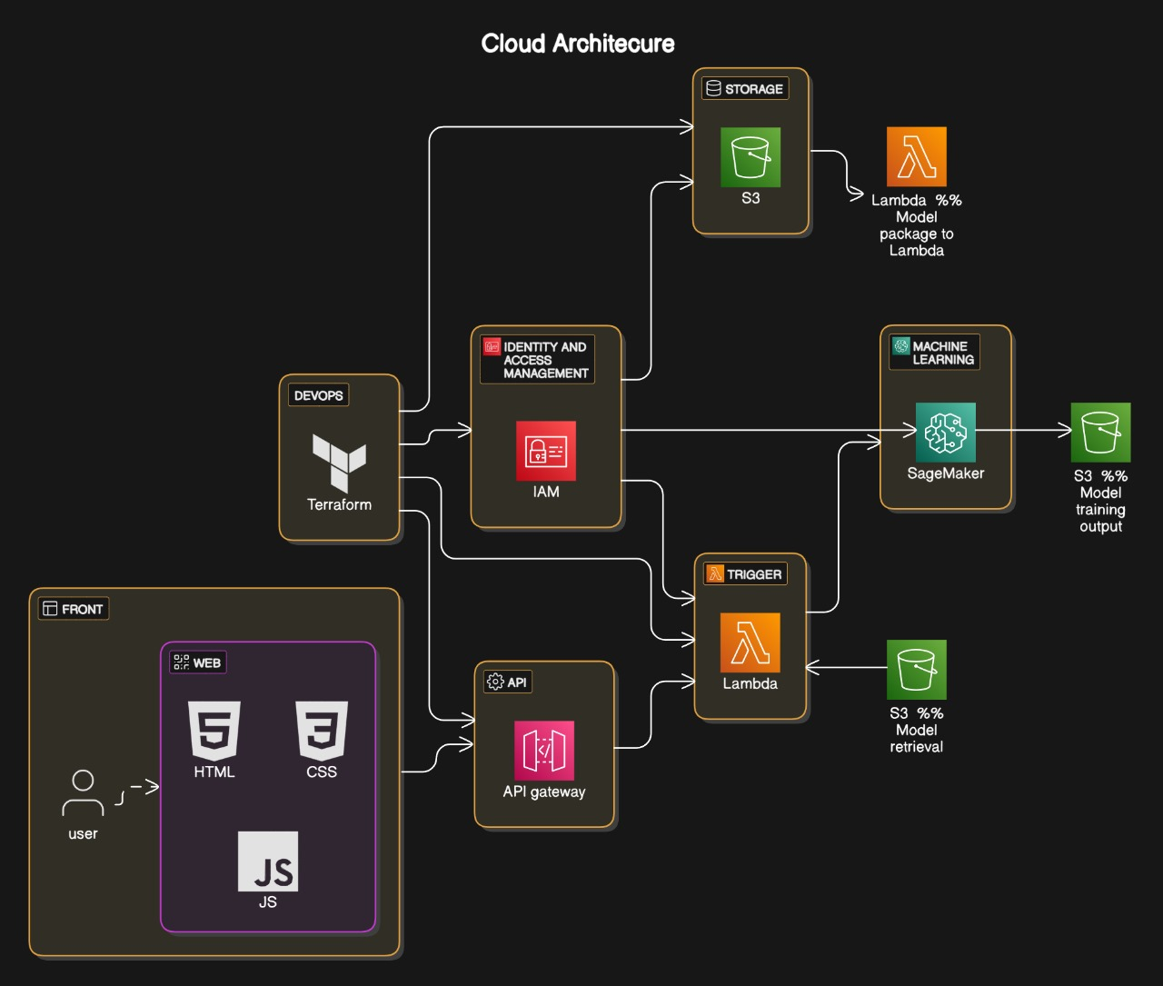

Architecture Components and Data Flow
1. Frontend (Web)
  - Components: HTML, CSS, JavaScript (JS)
  - Description: The user interacts with a static website hosted on Amazon S3. The webpage (index.html) uses JavaScript to send a POST request to the API Gateway with the user-provided URL.
  - Flow: User → Web (S3) → API Gateway

2. API Gateway
  - Description: Acts as the entry point for the frontend to communicate with the backend. It handles HTTP requests, including CORS preflight (OPTIONS) for browser compatibility.
  - Flow: Web → API Gateway → Lambda (Trigger)

3. AWS Lambda (Trigger and Model Retrieval)
  - Trigger: The API Gateway triggers the Lambda function (phishing_detector) to process the URL.
  - Model Retrieval: The Lambda function retrieves the pre-trained model (phishing_model.pkl) from S3.
  - Flow: API Gateway → Lambda → S3 (Model Retrieval)

4. Amazon S3 (Storage)
  - Description: Stores the static website (index.html), the Lambda function package (lambda_package.zip), the Lambda Layer package (lambda_layer.zip), and the machine learning model (phishing_model.pkl).
  - Flow:
    - S3 → Web (Static Hosting)
    - S3 → Lambda (Model Retrieval)
    - S3 → Lambda (Package to Lambda)

5. Machine Learning (SageMaker)
  - Description: The machine learning model was trained using Amazon SageMaker, which outputs the trained model (phishing_model.pkl) to S3.
  - Flow: SageMaker → S3 (Model Training Output)

6. Identity and Access Management (IAM)
  - Description: Manages permissions for secure interactions between services (e.g., Lambda accessing S3, API Gateway invoking Lambda).
  - Flow: IAM → Lambda, API Gateway, S3

7. DevOps (Terraform)
  - Description: Terraform automates the deployment of all AWS resources, ensuring consistency and repeatability.
  - Flow: Terraform → IAM, S3, Lambda, API Gateway

8. Additional Tools
  - CloudTrail: Monitors and logs API calls for auditing and security.
  - Docker: Used locally for development or training containers (e.g., SageMaker training).
  - Flow: CloudTrail → All Services (Auditing)

Architecture and Technology Stack

Services and Their Use Cases
1. Amazon S3: Utilized to host the static website, making it accessible to users via a public URL. It also serves as the storage solution for application assets, including the machine learning model, Lambda function code, and Lambda Layer packages.
2. AWS Lambda: Executes the machine learning prediction logic in a serverless environment, processing incoming URLs and returning predictions without the need for managing servers.
3. AWS Lambda Layer: Manages large dependencies to keep the Lambda function package size under the 250 MB unzipped limit, ensuring efficient deployment and execution of the prediction logic.
4. Amazon API Gateway: Provides a RESTful API endpoint that connects the frontend to the backend Lambda function, handling HTTP requests and enabling cross-origin resource sharing (CORS) for browser compatibility.
5. AWS IAM: Secures access between services by defining roles and policies, such as allowing Lambda to access S3 and permitting API Gateway to invoke the Lambda function.
6. Amazon SageMaker: Trains the machine learning model and outputs it to S3, enabling the Lambda function to use the trained model for predictions.
7. AWS CloudTrail: Logs API calls across all services for auditing, monitoring, and security analysis, ensuring compliance and facilitating debugging.
8. Terraform: Automates the deployment and management of AWS infrastructure as code, ensuring consistent and repeatable setups across environments.

Technology Highlights
1. Frontend:
  - Static HTML (index.html) hosted on S3 with JavaScript for API interaction.
  - Publicly accessible with a custom S3 website URL.
2. Backend:
  - AWS Lambda processes requests using predict.py (prediction logic) and FeatureExtractor.py (feature extraction).
  - Dependencies managed via a Lambda Layer to bypass the 250 MB unzipped size limit.

3. API Integration:
  - API Gateway handles HTTP requests, including CORS preflight (OPTIONS) for browser compatibility.

4. Machine Learning:
  - Pre-trained model (phishing_model.pkl) stored in S3, loaded by Lambda for predictions.
  - Trained using Amazon SageMaker for scalability and efficiency.

5. Infrastructure-as-Code:
  - Terraform deploys all resources, ensuring scalability and version control.

Deployment Details
Website URL: http://phishing-detection-bucket-314146319737.s3-website-us-east-1.amazonaws.com
API Endpoint: https://<api-id>.execute-api.us-east-1.amazonaws.com/prod/predict

Deployment Method: Terraform (terraform apply)
Status: Fully operational as of March 26, 2025
AWS Region: us-east-1

File Structure in S3
File | Purpose
1. index.html | Static webpage for user interaction
2. lambda_package.zip | Lambda function code (predict.py,  FeatureExtractor.py)
3. lambda_layer.zip | Lambda Layer with dependencies
4. phishing_model.pkl | Pre-trained machine learning model
5. FeatureExtractor.py | Feature extraction script
6. predict.py | Prediction logic for Lambda

Project Value
1. Enhanced Security Awareness
Provides users with a quick, reliable tool to verify website legitimacy, reducing the risk of phishing attacks.
2. Educational Demonstration
Showcases the practical application of machine learning in cybersecurity, bridging theory and real-world use.
3. Scalable Solution
Built on AWS serverless architecture, it can scale effortlessly to handle increased traffic or future enhancements.
4. Technical Proficiency

Highlights skills in:
1. Cloud Computing: AWS S3, Lambda, API Gateway, IAM, SageMaker, CloudTrail.
2. Machine Learning: Model training, deployment, and feature extraction.
3. Web Development: Static website hosting and API integration.
4. Infrastructure-as-Code: Terraform for automated deployments.
5. Containerization: Docker for local development and training.

Future Enhancements
1. UI Improvements
  - Add visual indicators (e.g., green for "Real," red for "Phishing") to enhance user experience.
  - Include a history log of checked URLs.
2. Model Expansion
  - Incorporate additional features (e.g., webpage content analysis, domain age, SSL certificate status).
  - Retrain the model periodically with updated phishing datasets.
3. Browser Integration
  - Develop a browser extension for seamless URL checking directly from webpages.
4. Performance Optimization
  - Cache frequent predictions in Amazon ElastiCache to reduce Lambda invocation latency.
  - Use AWS Step Functions for multi-step analysis workflows if additional processing is added.
5. Monitoring and Analytics
  - Integrate Amazon CloudWatch for real-time monitoring of Lambda performance and API Gateway usage.
  - Add user analytics to track popular URLs and prediction trends.

Project Details :

